**Ansible Task-3**

1. **Write a single ansible playbook which will install apache and nginx. Note: Playbook should not be hardcoded and pass the variables from different file.**

1) Set the ansible controller

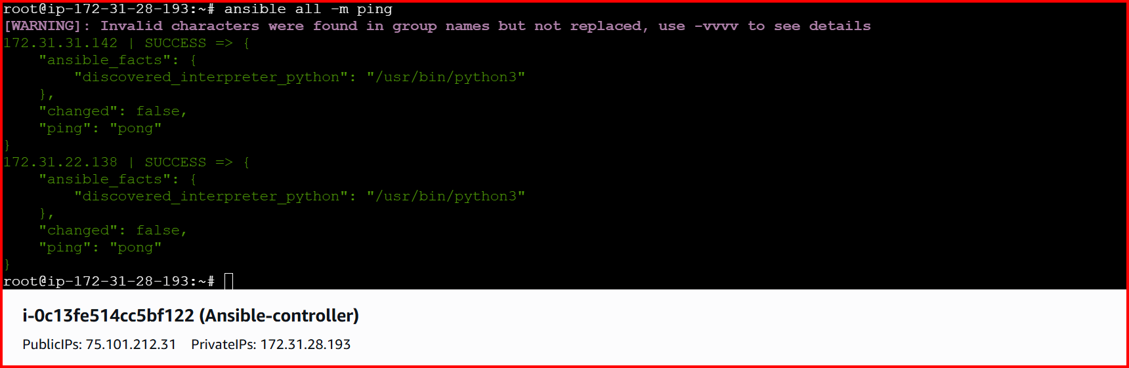

1. Create playbook
2. Create yml file 🡪 test.yml
3. mkdir -p vars
4. vi vars/webservers_vars.yml

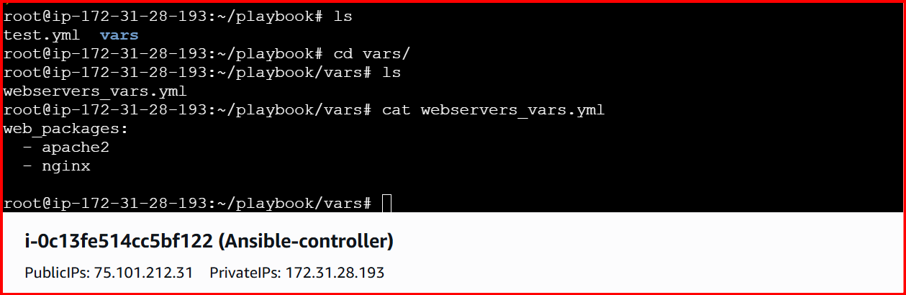

webservers_vars.yml

web_packages:

- httpd

- nginx

test.yml

---

- name: Install multiple web servers (apache, nginx) dynamically

hosts: all

become: yes

vars_files:

- ./vars/webservers_vars.yml

tasks:

- name: Ensure package cache is up-to-date (Debian/Ubuntu)

apt:

update_cache: yes

when: ansible_facts['pkg_mgr'] == "apt"

- name: Ensure package cache is up-to-date (RHEL/CentOS)

yum:

update_cache: yes

when: ansible_facts['pkg_mgr'] == "yum"

- name: Install required packages

package:

name: "{{ item }}"

state: present

loop: "{{ web_packages }}"

register: install_result

- name: Show install results

debug:

var: install_result

- name: Create Apache index page

copy:

dest: /var/www/html/index.html

content: "<h1>This is Apache2 page</h1>"

when: "'apache2' in web_packages or 'httpd' in web_packages"

- name: Create Nginx index page

copy:

dest: /usr/share/nginx/html/index.html

content: "<h1>This is Nginx page</h1>"

when: "'nginx' in web_packages"

---------------------------------------------------------------------------------------------------

Run these commands

ansible-playbook test.yml --syntax-check

ansible-playbook test.yml --check

ansible-playbook test.yml

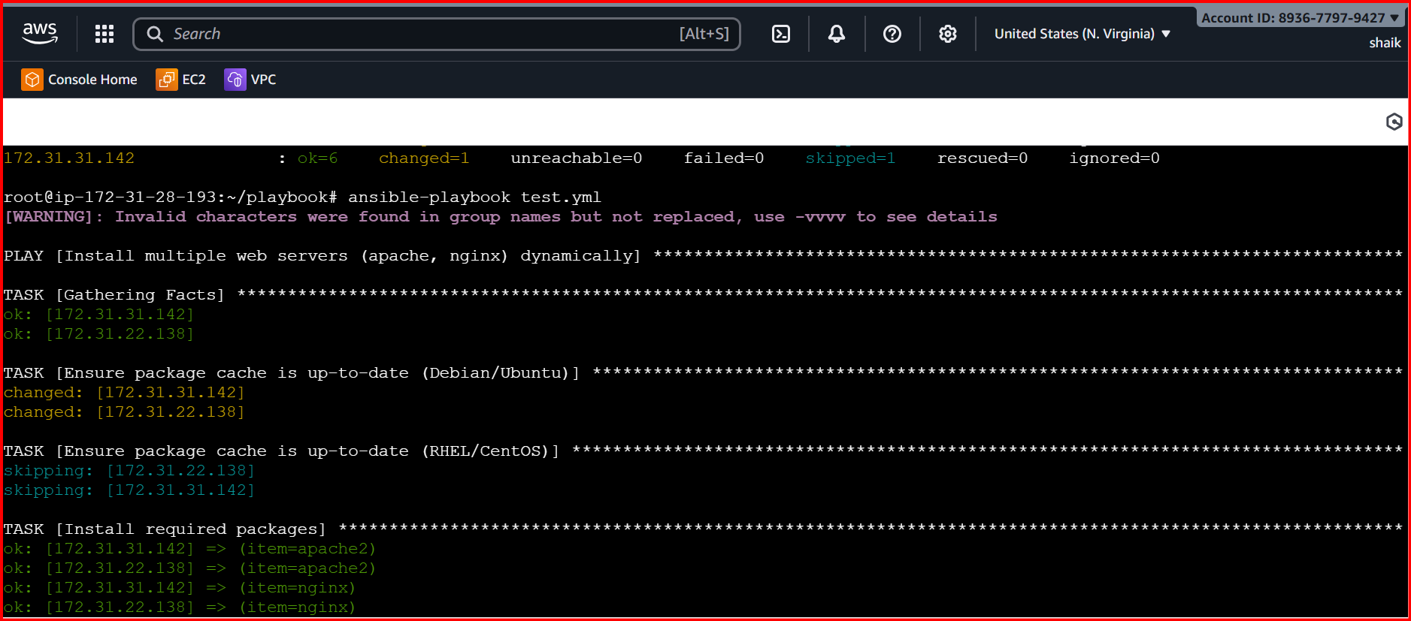

**ansible all -i /etc/ansible/hosts -b -m service -a "name=apache2 state=stopped"**

**ansible all -i /etc/ansible/hosts -b -m service -a "name=nginx state=started"**

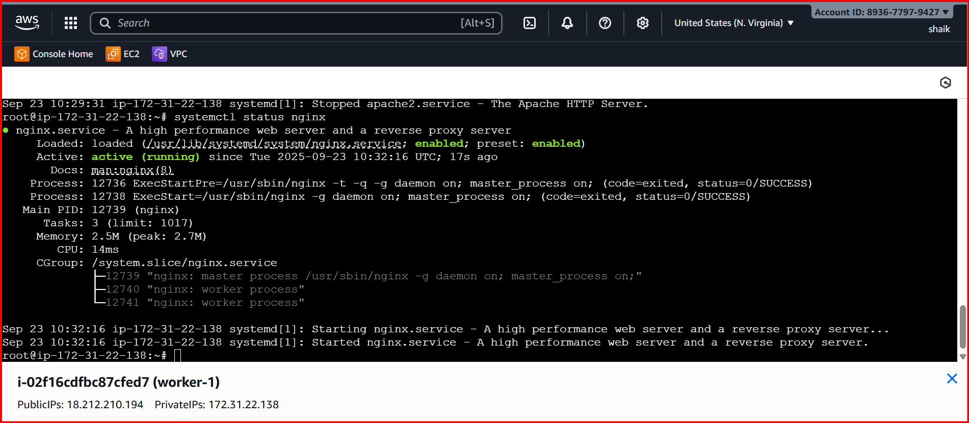



**2. Ansible playbook to create 10 different directories with minimal code and directory names should be passed as variables.**

Create

create_dirs.yml

---

- name: Create 10 directories with loop

hosts: all

become: yes

vars:

dir_list:

- /opt/dir1

- /opt/dir2

- /opt/dir3

- /opt/dir4

- /opt/dir5

- /opt/dir6

- /opt/dir7

- /opt/dir8

- /opt/dir9

- /opt/dir10

tasks:

- name: Create directories

file:

path: "{{ item }}"

state: directory

mode: '0755'

loop: "{{ dir_list }}"

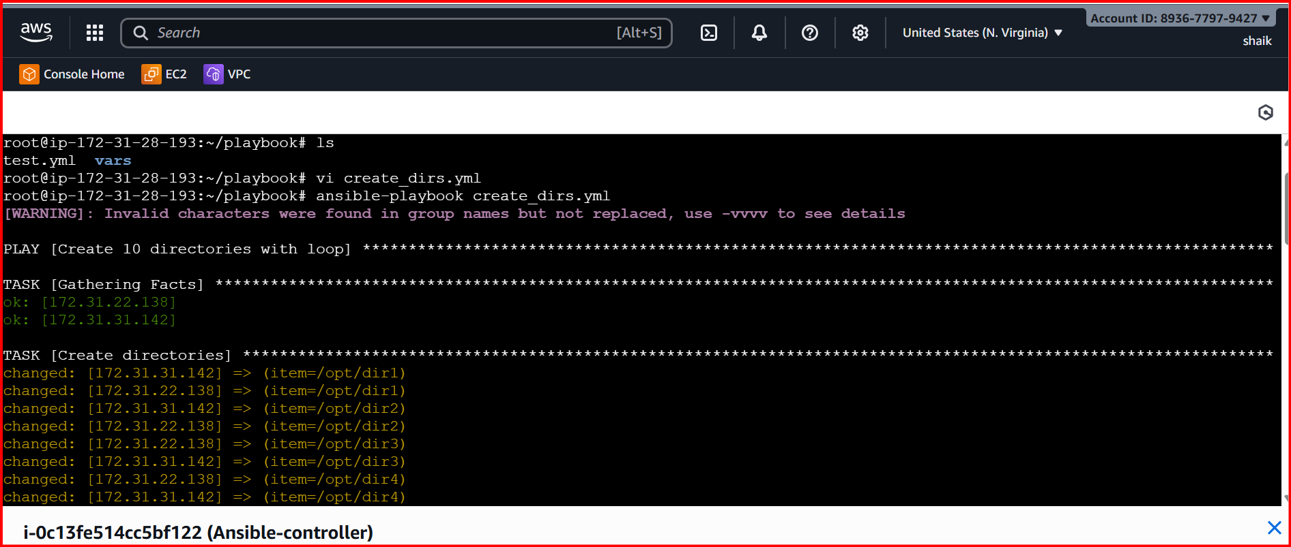

Check it worker servers

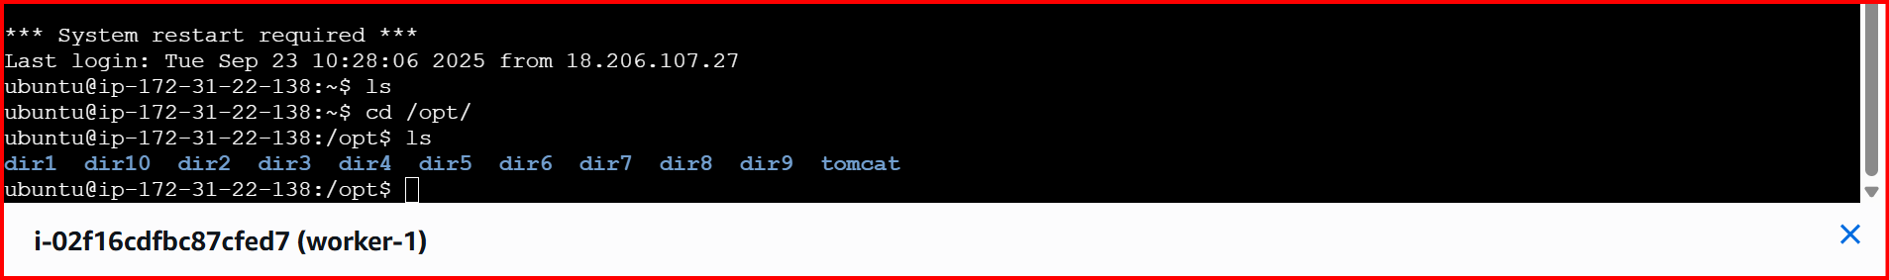

**4.Ansible playbook to inject ansible vault variables**

**Run this command**

**ansible-vault create vault.yml**

**set new password**

**create one yml**

**vi use_vault.yml**

**---**

**- name: Use Ansible Vault variables**

**hosts: all**

**become: yes**

**vars_files:**

**- vault.yml # Inject vault file**

**tasks:**

**- name: Show DB username**

**debug:**

**msg: "Database user is {{ vault_db_user }}"**

**- name: Show DB password**

**debug:**

**msg: "Database password is {{ vault_db_pass }}"**

**run this command :**

**ansible-playbook use_vault.yml --ask-vault-pass**

**this will ask you password : what you set first time**

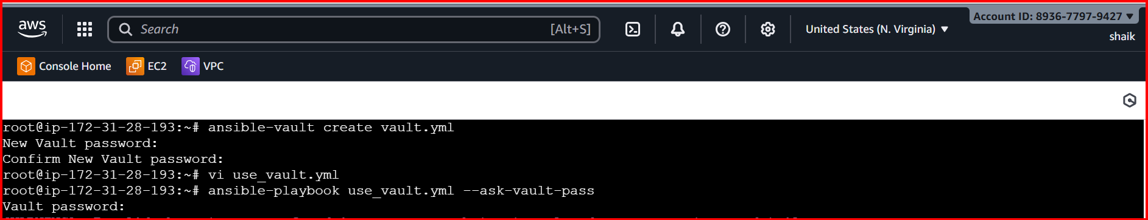

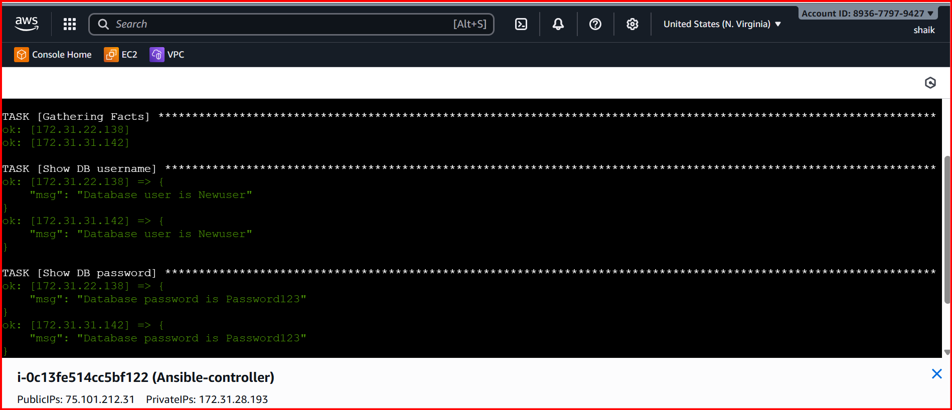

**3.Ansible playbook to copy ssh-keygen from master to worker nodes. Note: a)Provision new 3 ec2 machines, one master and two worker nodes. b)Create common user called ansadm and provide sudo priviliges on 3 ec2 instances. c)Create ssh-keygen in master and your playbook should copy the keygen making it password less authentication.**

1. **Provision new 3 ec2 machines, one master and two worker nodes.**

**Step 1: Install python3-venv**

**sudo apt update**

**sudo apt install python3-venv -y**

**Step 2: Create the virtual environment**

**python3 -m venv ~/ansible-venv**

**Step 3: Activate the virtual environment**

**source ~/ansible-venv/bin/activate**

**Your prompt should now show (ansible-venv) at the beginning.**

**Step 4: Install AWS packages inside the virtual environment**

**pip install boto3 botocore**

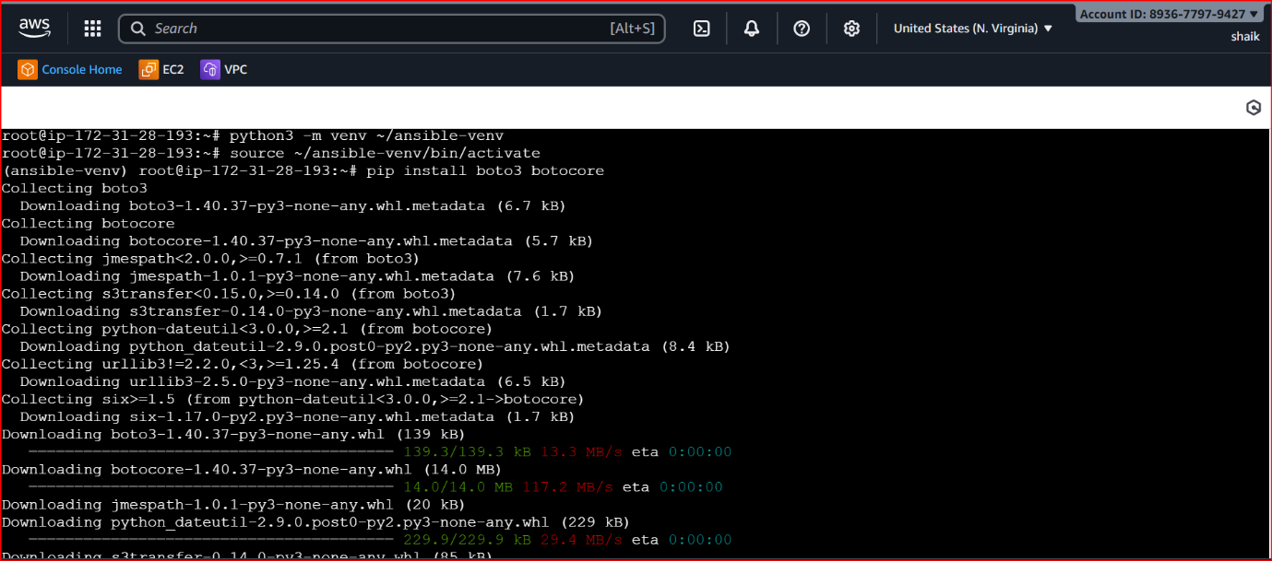



**Tip: Every time you start a new session, activate the venv first with source ~/ansible-venv/bin/activate.**

**AWS configuration:**

**curl "https://awscli.amazonaws.com/awscli-exe-linux-x86_64.zip" -o "awscliv2.zip"**

**sudo apt install unzip -y # if unzip is not installed**

**unzip awscliv2.zip**

**sudo ./aws/install**

**aws --version**

**aws configure**

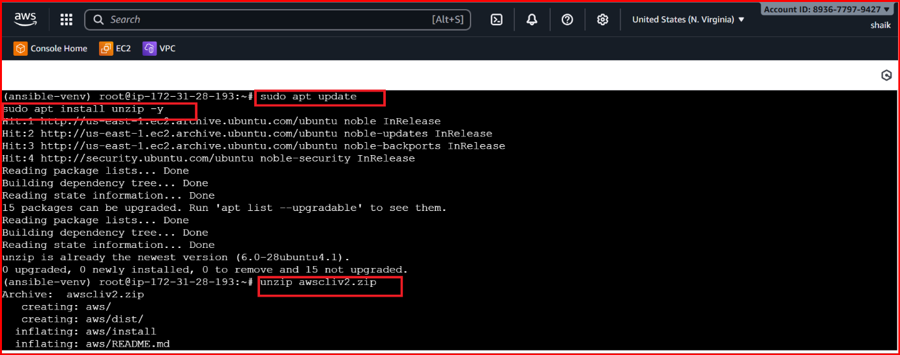

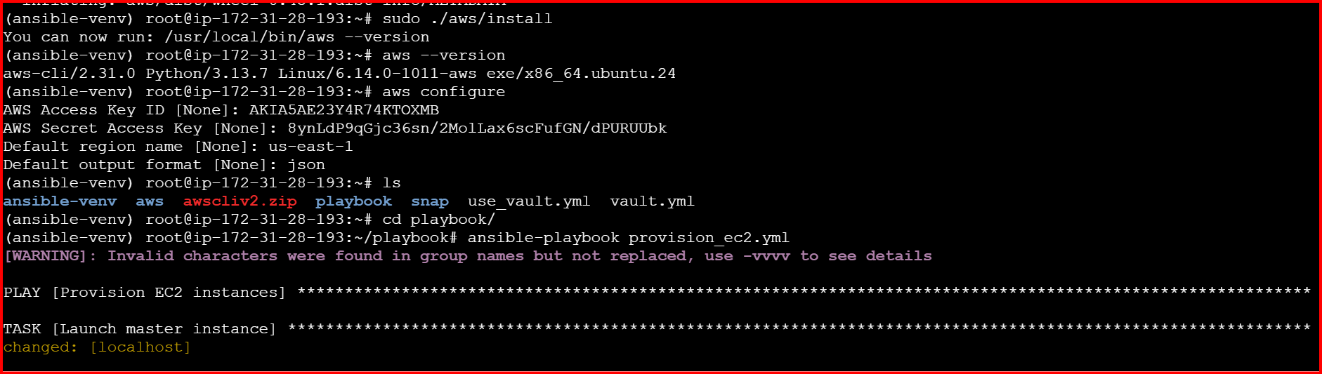

**create**

**provision_ec2.yml**

**---**

**- name: Provision EC2 instances**

**hosts: localhost**

**connection: local**

**gather_facts: false**

**vars:**

**region: us-east-1 # Change to your AWS region**

**key_name: aws # Replace with your AWS key pair name**

**instance_type: t3.micro**

**ami_id: ami-0360c520857e3138f # Amazon Linux 2 AMI (change for your region)**

**vpc_id: vpc-xxxxxxxx # Optional: your VPC ID**

**tasks:**

**- name: Launch master instance**

**amazon.aws.ec2_instance:**

**name: master**

**key_name: "{{ key_name }}"**

**instance_type: "{{ instance_type }}"**

**image_id: "{{ ami_id }}"**

**region: "{{ region }}"**

**wait: yes**

**register: master_instance**

**- name: Launch 2 worker instances**

**amazon.aws.ec2_instance:**

**name: worker**

**key_name: "{{ key_name }}"**

**instance_type: "{{ instance_type }}"**

**image_id: "{{ ami_id }}"**

**region: "{{ region }}"**

**count: 2**

**wait: yes**

**register: worker_instances**

**- name: Show EC2 instance details**

**debug:**

**msg:**

**- "Master Public IP: {{ master_instance.instances[0].public_ip_address }}"**

**- "Workers Public IPs: {{ worker_instances.instances | map(attribute='public_ip_address') | list }}"**

**Execute: ansible-playbook provision_ec2.yml**

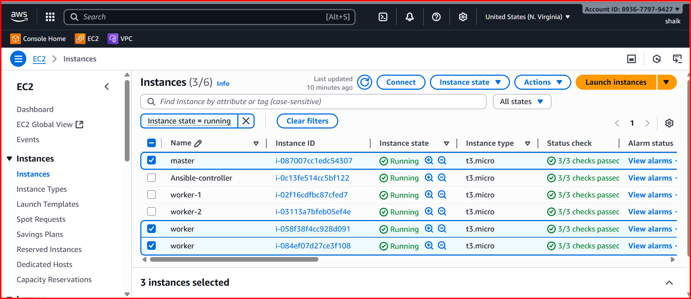

**b)Create common user called ansadm and provide sudo priviliges on 3 ec2 instances.**

**c)Create ssh-keygen in master and your playbook should copy the keygen making it password less authentication.**

Create vi hosts.ini

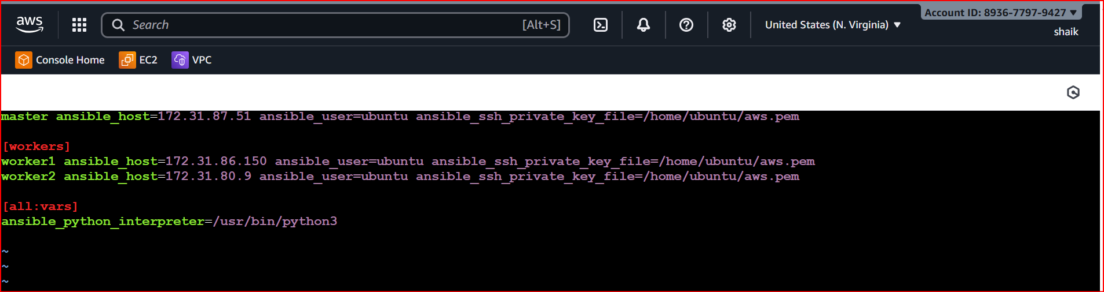

Create vi create_user.yml

- name: Setup ansadm user and passwordless SSH

hosts: all

become: yes

tasks:

# 1. Create ansadm user

- name: Ensure ansadm user exists

user:

name: ansadm

shell: /bin/bash

state: present

create_home: yes

# 2. Add ansadm to sudoers

- name: Add ansadm to sudoers

copy:

dest: /etc/sudoers.d/ansadm

content: "ansadm ALL=(ALL) NOPASSWD:ALL"

owner: root

group: root

mode: '0440'

- name: Generate SSH key on master

hosts: master

become: yes

tasks:

- name: Generate SSH key for ansadm

user:

name: ansadm

generate_ssh_key: yes

ssh_key_bits: 2048

ssh_key_file: .ssh/id_rsa

- name: Copy SSH key from master to workers

hosts: workers

become: yes

tasks:

- name: Fetch master's public key

fetch:

src: /home/ansadm/.ssh/id_rsa.pub

dest: /tmp/ansadm_id_rsa.pub

flat: yes

delegate_to: master

- name: Add master's public key to worker's authorized_keys

authorized_key:

user: ansadm

state: present

key: "{{ lookup('file', '/tmp/ansadm_id_rsa.pub') }}"

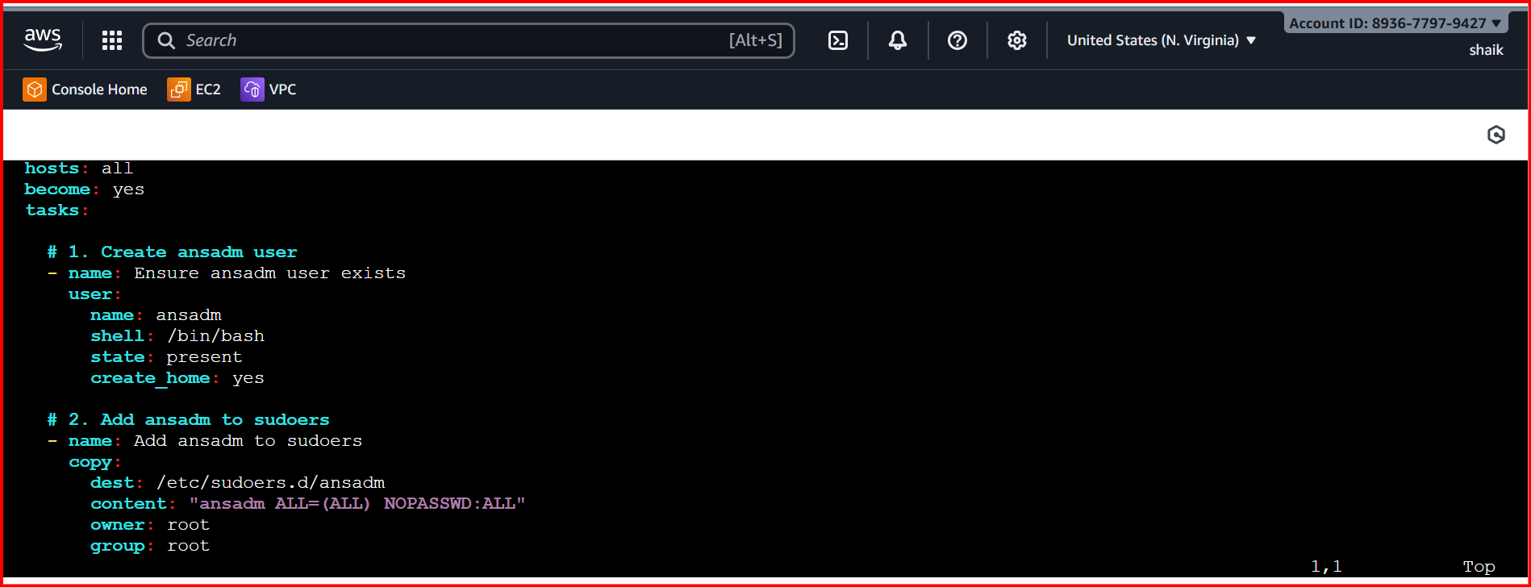

ansible all -i hosts.ini -m ping

